H.T No
Regulations:
A20

Sreenidhi Institute of Science and Technology
(An Autonomous Institution)
Code No:8D301 Date: 21-September-2024 (FN)

B.Tech II-Year I- Semester External Examination, September-2024 (Supplementary)
DISCRETE STRUCTURES AND GRAPH THEORY (ECM)

Time: 3 Hours Max.Marks:70

Note: a) No additional answer sheets will be provided.
b) All sub-parts of a question must be answered at one place only, otherwise it will not be valued.
c) Missing data can be assumed suitably.

Bloom's Cognitive Levels of Learning (BCLL)

Remember | L1 | Apply | L3 | Evaluate | L5
Understand | L2 | Analyze | L4 | Create | L6

Part - A Max.Marks:20
Answer all QUESTIONS

 |  | BCLL | CO(s) | Marks
1 | What is Well Formed Formulae | L 2 | CO1 | [2M]
2 | What are Free and Bound Variables | L 2 | CO2 | [2M]
3 | What is Equivalence Relation? Give an Example | L 3 | CO3 | [2M]
4 | State Principle of Inclusion and Exclusion | L 2 | CO4 | [2M]
5 | What is a Generating Function, Explain with Example | L 3 | CO5 | [2M]
6 | What is Planar graph, is k_{3,3} Planar | L 2 | CO6 | [2M]
7 | What is automatic theorem proving | L 3 | CO1 | [2M]
8 | Define group and its properties. | L 2 | CO3 | [2M]
9 | What is homogeneous Recurrence Relation. Give an example. | L 3 | CO5 | [2M]
10 | Define spanning tree with example. | L 2 | CO6 | [2M]
Part – B Max.Marks:50
ANSWER ANY FIVE QUESTIONS. EACH QUESTION CARRIES 10 MARKS.

 |  |  | BCLL | CO(s) | Marks
11. | a) | Show that  (P → ¬Q) ∧ (P → ¬R) ⟺ ¬ (P ∧ (Q∨R)) | L2 | CO1 | [5M]
 | b) | Find the principal disjunctive normal form of  P→ {(P→Q) Λ ¬(¬Q V ¬P)} | L3 | CO1 | [5M]
12. | a) | What are the types of quantifier?  Write each of the following in symbolic form.  i) All men are good  (ii) No men are good  iii) Some men are good  (iv) Some men are not good | L3 | CO2 | [5M]
 | b) | Prove that | L3 | CO2 | [5M]
13. | a) | What is compatibility relation? Let X={ ball, bed, dog, let, egg} and let the relation R be given by R={(x, y): xRy if x and y contain some common letter}. Verify whether the relation is a compatibility relation? | L3 | CO3 | [5M]
 | b) | Describe bijective function. Find whether the following functions are bijective or not and also find the inverse of the function  i. f(x)= 4x+2, where A= set of real numbers  ii. f(x)=3+1/x, where A= set of non-zero real number | L3 | CO3 | [5M]
14. | a) | How many 3 digit numbers can be formed using 1,3,4,5,6,8,9 and how many can be formed if no digit can be repeated? | L2 | CO4 | [5M]
 | b) | Determine the coefficients of a²b³c²d⁵ in the expansion of (a+2b-3c+2d+5)¹⁶ | L3 | CO4 | [5M]
15. | a) | Evaluate a_{n}-6a_{n-1}+9a_{n-2} =0 for n >= 2 given a₀=5, a₁=12. | L3 | CO5 | [5M]
 | b) | Solve the recurrence relation  a_{n}-6a_{n-1}+9a_{n-2}=7.3^{n} , for n>=2 | L3 | CO5 | [5M]
16. | a) | Prove that the chromatic number of a tree and Bipartite graph is always 2 & chromatic number  of Complete graph K_{n} is n . | L3 | CO6 | [5M]
 | b) | Using prims algorithm find a minimal spanning tree for the weighted graph shown below  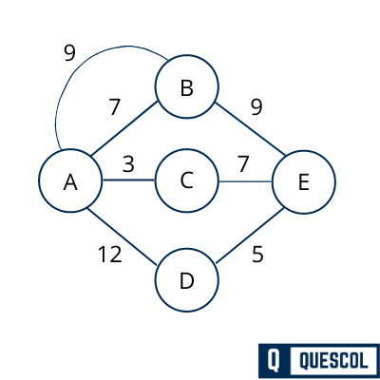 | L3 | CO6 | [5M]
17. | a) | Prove the following logical equivalence without constructing the Truth Table.  [P ∨ Q ∨ (¬P Λ ¬Q Λ R)] ⟺ (P ∨ Q ∨ R) | L3 | CO1 | [4M]
 | b) | using automatic theorem proving prove the following  i. | L3 | CO2 | [3M]
 | c) | If o is an operation on Z defined by x o y=x+y+2 prove that (z , o) is an abelian group | L3 | CO3 | [3M]
18. | a) | In how many ways can 23 different books be given to 5 students so that 2 of the students will have 4 books each and the other 3 will have 5 books each? | L2 | CO4 | [4M]
 | b) | Solve the recurrence relation a_{n}-4a_{n-1}+4a_{n-2}=0. | L3 | CO5 | [3M]
 | c) | Explain isomorphism of two graphs? Check whether the given graphs G1 and G2 are isomorphic or not? Give reasons.  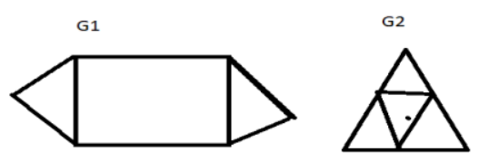 | L3 | CO6 | [3M]

-- 00 -- 00 –

